**数组题目运行截图：**

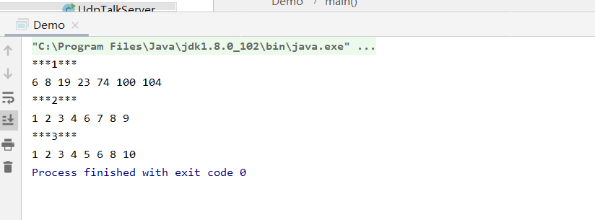

**public class** Demo {  
 **public static void** main(String[] args) {  
 System.***out***.println(**"***1***"**);  
 **int**[] ver = {100,23,6,74,8,19,104};  
 **for** (**int** i = 0; i < ver.**length**; i++) {  
 **for**(**int** j = i + 1 ; j < ver.**length** ; j++){  
 **if** (ver[i]>ver[j]){  
 **int** tem = ver[i];  
 ver[i] = ver[j];  
 ver[j] = tem;  
 }  
 }  
 System.***out***.print(ver[i]+**" "**);  
 }  
 System.***out***.println(**"\n***2***"**);  
 **int**[] Lis = {1,2,3,4,5,5,5,5,5,6,7,8,9};  
 **int**[] Lis2 = **new int**[Lis.**length**+1];  
 **int** index = 0;  
 **for** (**int** i = 0; i < Lis.**length**; i++) {  
 **if** (Lis[i]==5){  
 **continue**;  
 }  
 Lis2[index]=Lis[i];  
 System.***out***.print(Lis2[index++]+**" "**);  
 }  
  
 System.***out***.println(**"\n***3***"**);  
 **int**[] A = {1,3,5,7,9};  
 **int**[] B = {2,4,6,8,10};  
 **int**[] C = **new int**[A.**length**+B.**length**+1];  
 **int** i,j,t;*//分别指示A B C数组的下标* **int** len = (A.**length**<B.**length**?A.**length**:B.**length**);*//取A B数组长度较小的那个值* **for** (i = 0,j = 0,t = 0; t < len; t++) {  
 **if**(i<A.**length** && A[i]<=B[j]){  
 C[t] = A[i++];  
 }  
 **else if** (j<B.**length** && B[j]<A[i]){  
 C[t] = B[j++];  
 }  
 System.***out***.print(C[t]+**" "**);  
 }  
 **if** (len==A.**length**){  
 **for** (;j<B.**length**;j++){  
 C[t]=B[j];  
 System.***out***.print(C[t++]+**" "**);  
 }  
 }  
 **else**{  
 **for** (;i<A.**length**;i++){  
 C[t]=A[i];  
 System.***out***.print(C[t++]+**" "**);  
 }  
 }  
 }  
}

字符串题目运行截图：

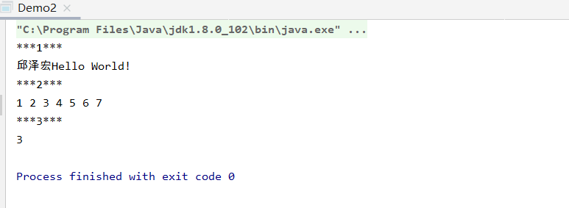

System.***out***.println(**"***1***"**);  
String str = **"Hello World!"**;  
String str2 = **"邱泽宏"**;  
System.***out***.println(str2.concat(str));  
  
System.***out***.println(**"***2***"**);  
String str3 = **"1,2,3,4,5,6,7"**;  
String [] strS;  
strS=str3.split(**","**);  
**for** (String s : strS){  
 System.***out***.print(s+**" "**);  
}  
System.***out***.println(**"\n***3***"**);  
String str4 = **"Hello World!"**;  
**int** c = 0 ;  
**for** (**int** i = 0; i < str4.length(); i++) {  
 **if** (str4.charAt(i) == **'l'**){  
 c++;  
 }  
}  
System.***out***.println(c);